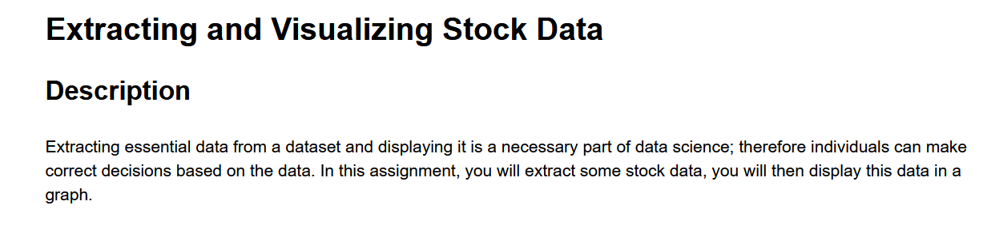

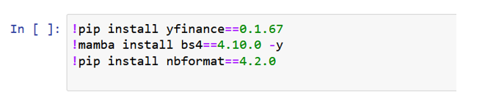

!pip install pandas <-- needed to add this to the lab

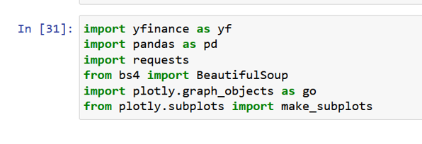

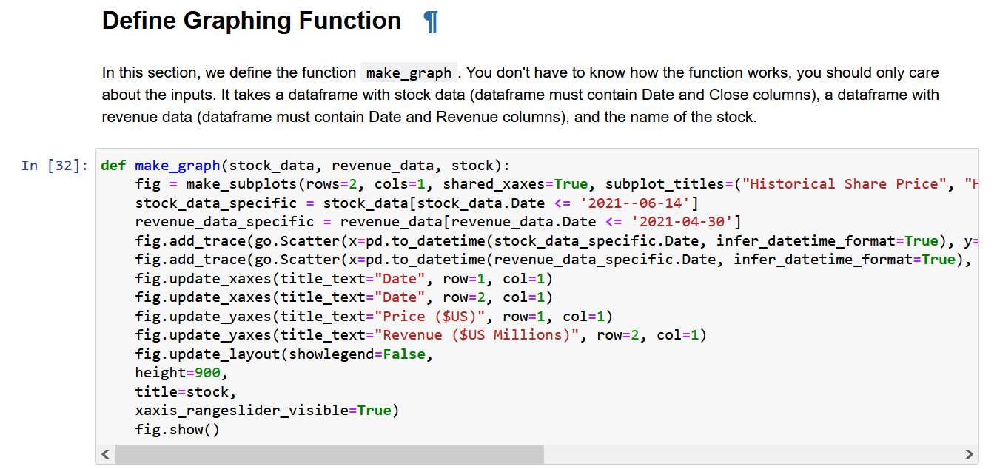

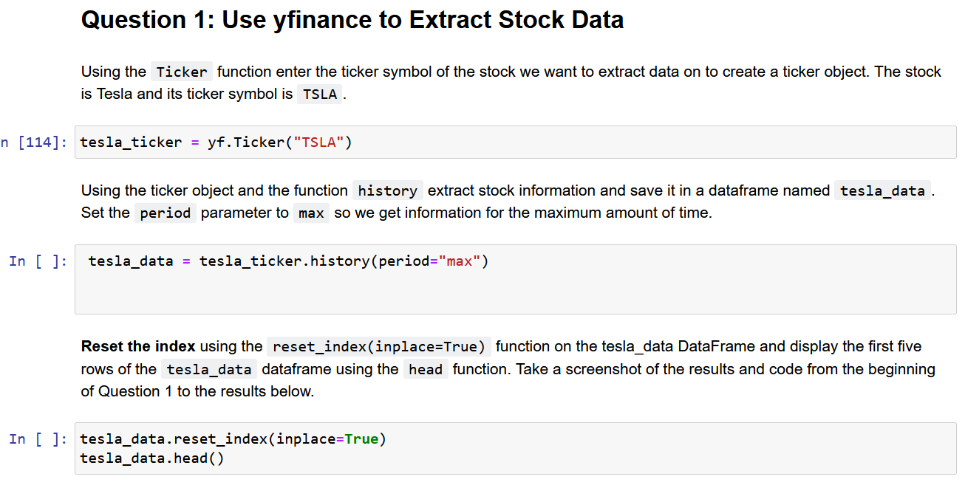

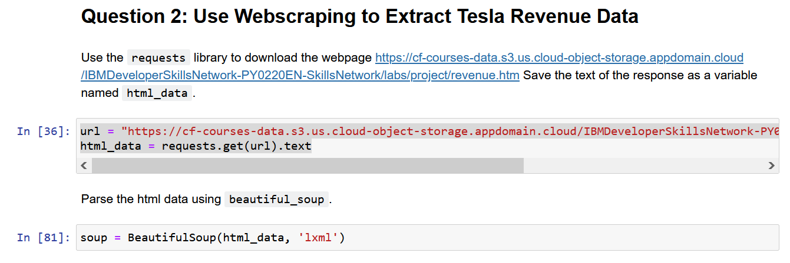

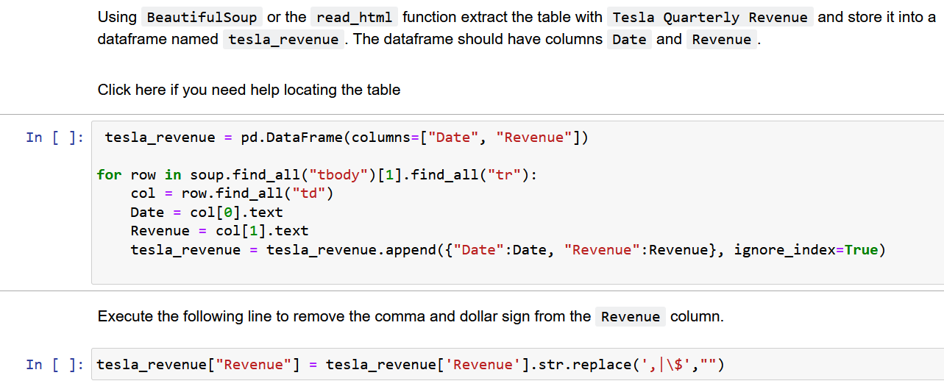

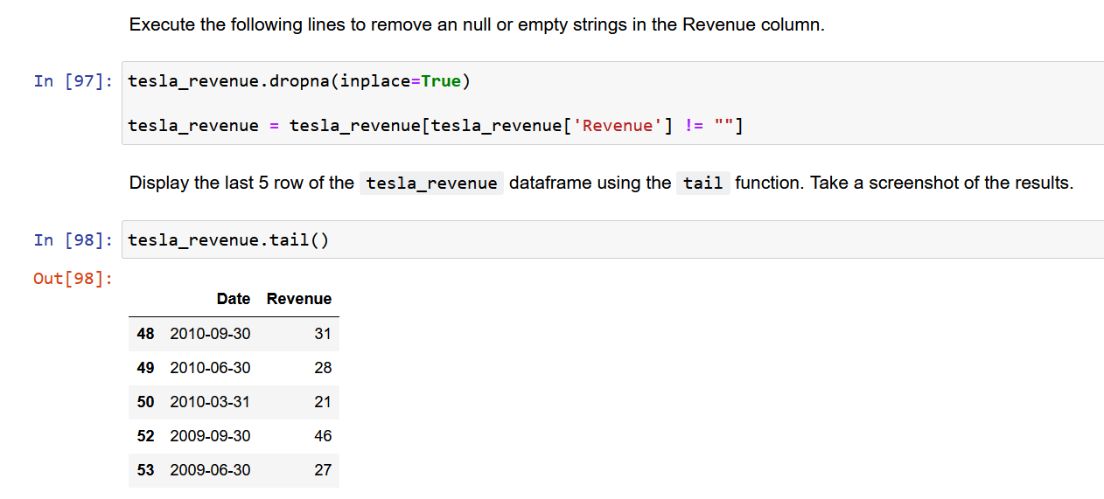

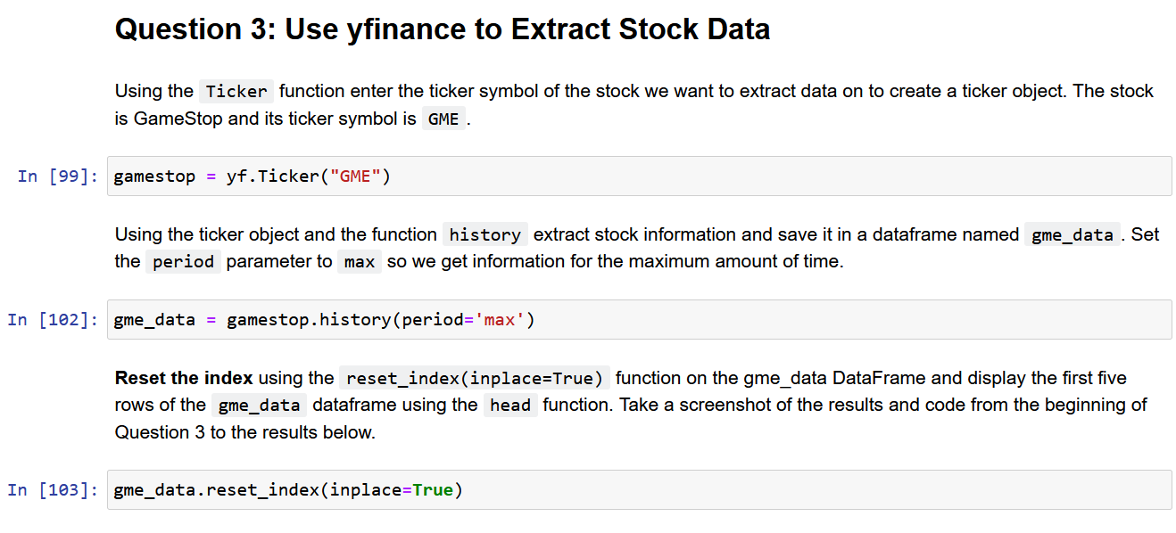

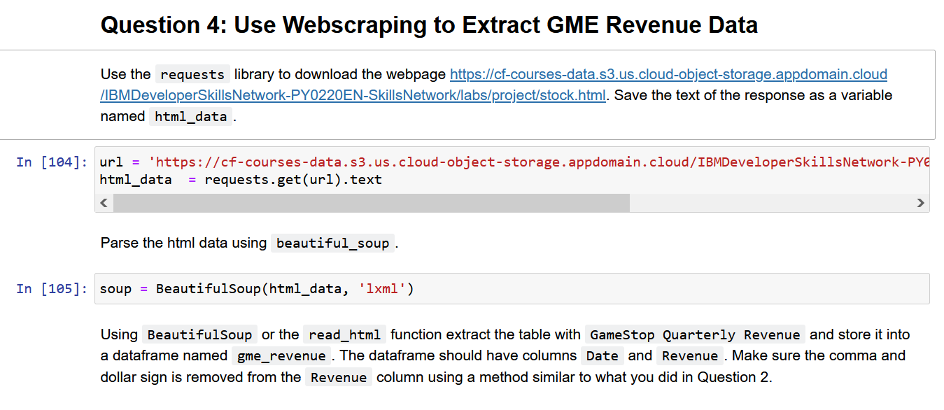

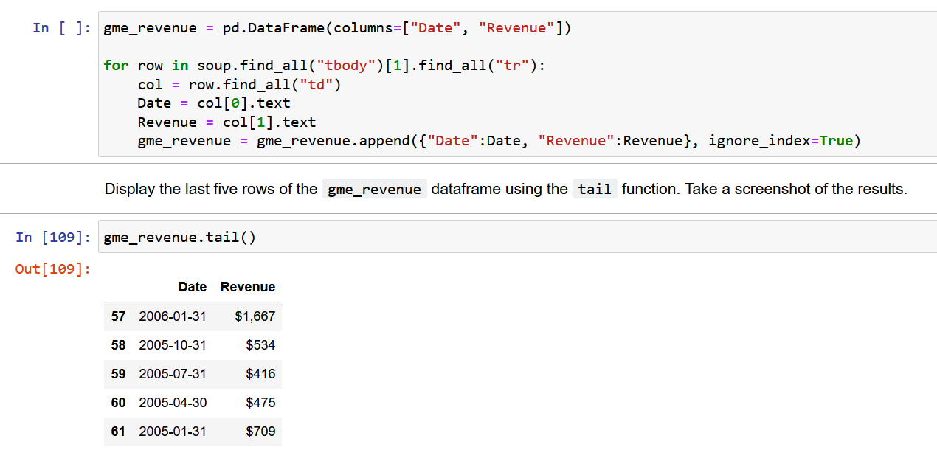

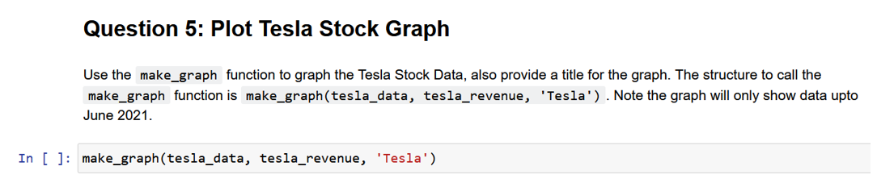

1. IBM Cloud would not allow me to log in. (2) The Coursera Feature code did not allow me to log into IBM Cloud, either. (3) IBM customer service could not resolve the problem, so I could not graph in IBM Cloud. (4) The Coursera code in this Final Assignment is so bad that it broke my local Jupyter app every time, even after I reinstalled Jupyter. (5) There was no way that I could actually create and display the graph.

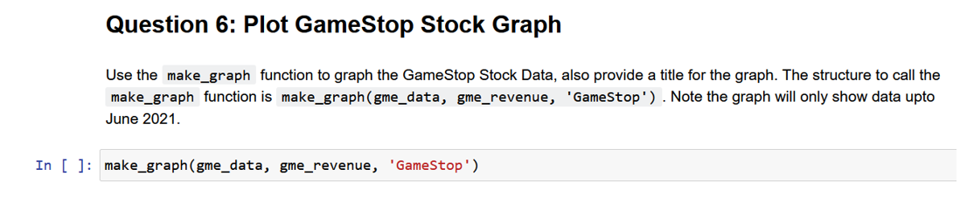

1. IBM Cloud would not allow me to log in. (2) The Coursera Feature code did not allow me to log into IBM Cloud, either. (3) IBM customer service could not resolve the problem, so I could not graph in IBM Cloud. (4) The Coursera code in this Final Assignment is so bad that it broke my local Jupyter app every time, even after I reinstalled Jupyter. (5) There was no way that I could actually create and display the graph.